**PROJECT**

**NAME :- JUNNA RAKESH**

**EMAIL:** [**junna.rakesh@gmail.com**](mailto:junna.rakesh@gmail.com)

**Batch no and Timing :- 112 & 12 pm**

**Trainer :- MadhukarReddy Sir**

# PIPELINE SYNTAX:-

# pipeline {

# agent any

# stages {

# stage('clone') {

# steps {

# checkout scmGit(branches: [[name: '*/DEV']], extensions: [], userRemoteConfigs: [[credentialsId: 'tomcat', url: 'https://github.com/Rakee12345/raviLogin.git']])

# }

# }

# stage('build'){

# steps{

# sh"mvn package"

# }

# }

# 

# stage('dev'){

# steps{

# deploy adapters: [tomcat9(credentialsId: 'tomcat', path: '', url: 'http://51.20.74.207:8081/')], contextPath: 'tomcat', war: '*/.war'

# }

# }

# 

# stage('test'){

# steps{

# deploy adapters: [tomcat9(credentialsId: 'tomcat', path: '', url: 'http://51.20.74.207:8081/')], contextPath: 'test', war: '*/.war'

# }

# }

# 

# stage('pre-pod'){

# steps{

# deploy adapters: [tomcat9(credentialsId: 'tomcat', path: '', url: 'http://51.20.74.207:8081/')], contextPath: 'prepod', war: '*/.war'

# }

# }

# 

# stage('production'){

# steps{

# deploy adapters: [tomcat9(credentialsId: 'tomcat', path: '', url: 'http://51.20.74.207:8081/')], contextPath: 'production', war: '*/.war'

# }

# }

# }

# }

**PIPELINE OUTPUT:-**

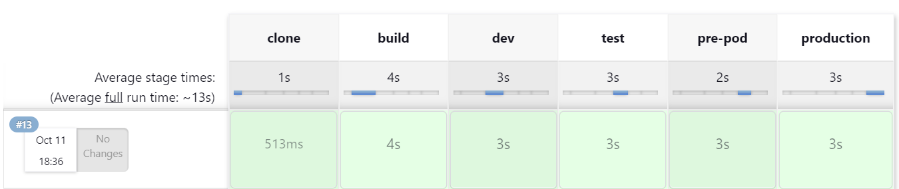

**TOMCAT OUTPUT :-**

